Our Business Plan 2020

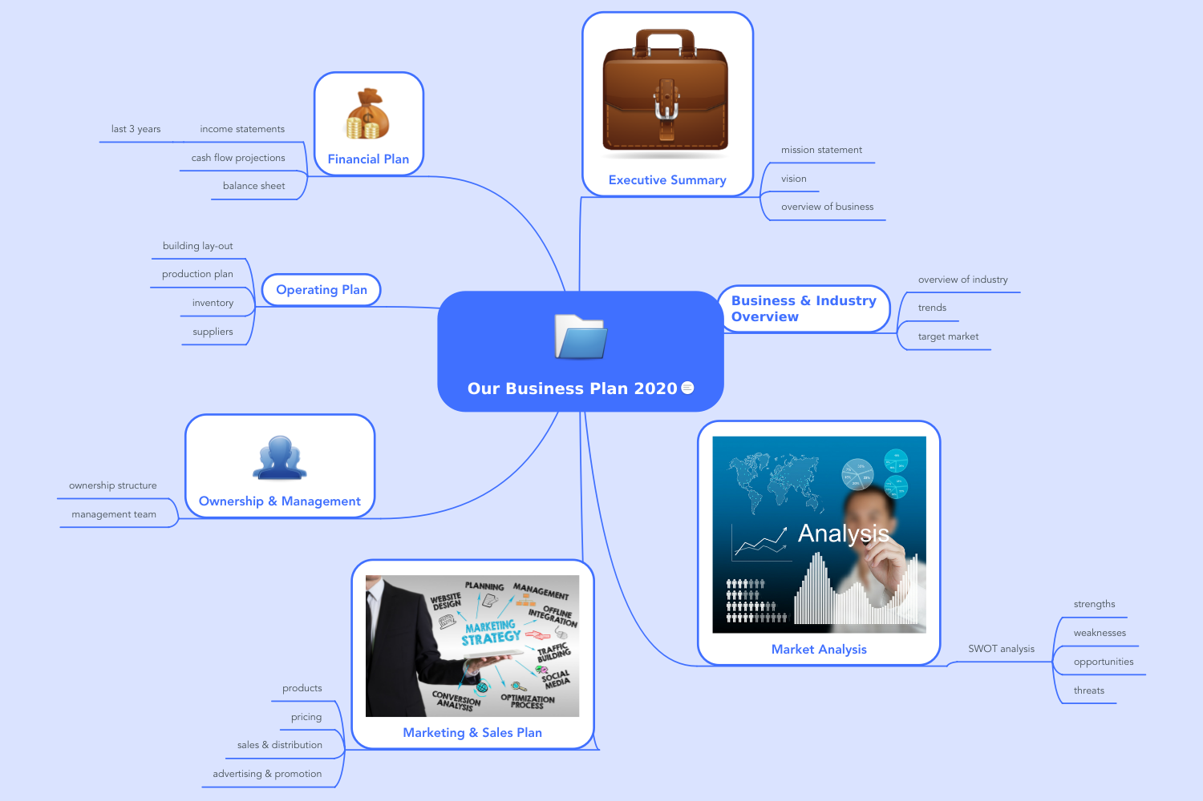
Contents
1 Executive Summary 5
1.1 mission statement 5
1.2 vision 5
1.3 overview of business 5
2 Business & Industry Overview 6
2.1 overview of industry 6
2.2 trends 6
2.3 target market 6
3 Market Analysis 7
3.1 SWOT analysis 8
3.1.1 strengths 8
3.1.2 weaknesses 8
3.1.3 opportunities 8
3.1.4 threats 8
4 Marketing & Sales Plan 9
4.1 products 10
4.2 pricing 10
4.3 sales & distribution 10
4.4 advertising & promotion 10
5 Ownership & Management 11
5.1 ownership structure 11
5.2 management team 11
6 Operating Plan 12
6.1 building lay-out 12
6.2 production plan 12
6.3 inventory 12
6.4 suppliers 12
7 Financial Plan 13
7.1 income statements 13
7.1.1 last 3 years 13
7.2 cash flow projections 13
7.3 balance sheet 13

Executive Summary

mission statement

vision

overview of business

Business & Industry Overview

overview of industry

trends

target market

Market Analysis

SWOT analysis

strengths

weaknesses

opportunities

threats

Marketing & Sales Plan

products

pricing

sales & distribution

advertising & promotion

Ownership & Management

ownership structure

management team

Operating Plan

building lay-out

production plan

inventory

suppliers

Financial Plan

income statements

last 3 years

cash flow projections

balance sheet

